# Project Report

|  |  |
| --- | --- |
| **Product Name** | Advanced Certificate in Web Development |
| **Qualification Name (ITSF)** | NICF-Advanced Certificate in Information Technology (Software & Applications) |
| **Product Name** | NICF-UI Frameworks |
| **Module Name (ITSF)** | NICF-UI Frameworks |

|  |  |  |  |
| --- | --- | --- | --- |
| **Student name** | | **Assessor name** | |
| Chathushi Jayarathna | | Mrs.Aravidar | |
| **Date issued** | **Completion date** | | **Submitted on** |
| 14/07/2022 | 16/07/2022 | | 22/08/2022 |
|  | | | |
| **Project title** | **Design & Develop Front End Community Portal RIA application.** | | |

|  |
| --- |
| **Learner declaration** |
| I certify that the work submitted for this assignment is my own and research sources are fully acknowledged.  Student signature:Chathushi Date: 22/08/2022 |

Table of Contents

Project Report 1

01) Project Background 4

➢ **Project Definition** 4

➢ **Project Objective** 4

02) Business Process and Solution Architecture 12

04) User Experience on 2 community portal websites 18

**1.** **Linkedin.com** 18

**2.** **Glassdoor.com** 19

05) Analyze the user experience based on the observations 19

06) The performance level & gaps between user experience & desired user experience along with level of user engagement 23

**07)** **User Interaction Process along with the flow chart** 30

08) File for the details of the widget prototypes 32

09) Usability tests and execute the usability test with a user 36

10) Gather feedback for the prototypes and document, make suggestions for improvement. 39

**11)** **Prototype and Wireframe File** 40

Table of Figure

Figure 1: Screenshot of visual studio code 7

Figure 2: screenshot of axure RP 10 8

Figure 3:Screenshot of Angular CLI 8

Figure 4:Screenshot of Regi.Drawio 9

Figure 5:Screenshot of Google Chrome 10

Figure 6:Screenshot of Microsoft Excel 10

Figure 7:Screenshot of Microsoft Word 11

Figure 8: Screenshot of powerpoint 11

Figure 9:Business Process and Solution Architecture 12

Figure 10:Screenshot of LinkedIn 18

Figure 11:Screenshot of Glassdoor.com Home Page 19

Figure 12:Screenshot of LinkedIn Registration Form 20

Figure 13:Screenshot of LinkedIn Login Form 21

Figure 14:Screenshot of Glassdoor Registration 21

Figure 15:Screenshot of Glassdoor Login 22

Figure 16:Screenshot of home page(prototype) 24

Figure 17:Screenshot of Login page (prototype) 25

Figure 18:Screenshot of forgot password(prototype) 25

Figure 19:Screenshot of forgot password confirmation (prototype) 26

Figure 20:Screenshot of registration (prototype) 26

Figure 21:Screenshot of registration confirmation (prototype) 27

Figure 22:Screenshot of registration thank you page (Prototype) 27

Figure 23:Screenshot of user profile page (prototype) 28

Figure 24:Screenshot of update profile (prototype) 28

Figure 25:Screenshot of search user page (prototype) 29

Figure 26:Screenshot of flow of Login 30

Figure 27:Screenshot of Flow of Registration 31

Figure 28:Screenshot of Registration Page 32

Figure 29:Screenshot of Login page 33

Figure 30:Screenshot of Home page 35

Figure 31:Screenshot of profile page before edit 39

Figure 32:Screenshot of profile page after edit 39

# Project Background

* **Project Definition**

ABC Jobs Pte Ltd as a website developer to develop a community portal for software developers. The scope of the project is to design a community portal similar to Linkedin.com. The platform is primarily used for professional networking and career development, allowing job seekers to post their CVs and job to employers.

According to this project

Using the registration page user can register to the community portal and using the login form users can log in by entering their email/username and password. Only registered users can log in to their profile (community portal). If a user forgets their password, they can recover the password also. After registration users can see user profiles and they can update some features in it. And they can find people, using the search bar in it, and can connect with them also. Mainly angular, HTML, CSS, and bootstrap are used to implement this community portal.

* **Project Objective**
* **Create Wireframes & Prototypes**

The software programmers of ABC Jobs Pte Ltd make wireframes and prototypes of what the community portal needs Such as the Community portal Home page, Registration page, registration confirmation page, Update profile page, Search users page, List search results, Public profile page, Registration confirmation email, login page, Forget password page and password confirmation page

* **Angular Installation & Working on it**

Step 1 - Install NodeJS

* Follow the link - https://nodejs.org/en/download/

Step 2 - Download the node.js installer for Windows and install it.

* npm -v (type in cmd)

Step 3 - Install TypeScript

* Open the link https://www.npmjs.com/package/typescript
* npm install -g typescript (type in cmd)

Step 4 - Install Angular CLI (Angular command line interface)

* Open the link https://cli.angular.io/ and follow the instructions to install Angular CLI and to create your first Angular app.
* npm install -g @angular/cli
* ng new <file name>
* open local host: 4200 using command
* ng serve --open

Step 5 – After successful installation, we can implement a community portal

* Functional Requirements
* Community Portal Home Page – Page with Login and Sign in button
* Registration page – Form to register to the community portal
* Registration thank you Page – Thank you page for registration
* Login Page – Login form to ententer the community portal
* Forgot Password – user can request to reset their password
* Forgot password confirmation page – To confirm Email
* Public profile – Once users register to this community portal, they can see their profile
* Update Profile – Using this users can update their profile like profile picture, skills, education etc.
* Search user page – users can search other users using this page.
* **User Research**
* Conducting user interviews
* Ideations – Creating personas
* **UX Testing**

The simplest definition of UX or user experience testing is the process of testing all the different elements and aspects of an application to arrive at an iteration that provides the best possible user experience.

* **Tools and Platforms used**
* 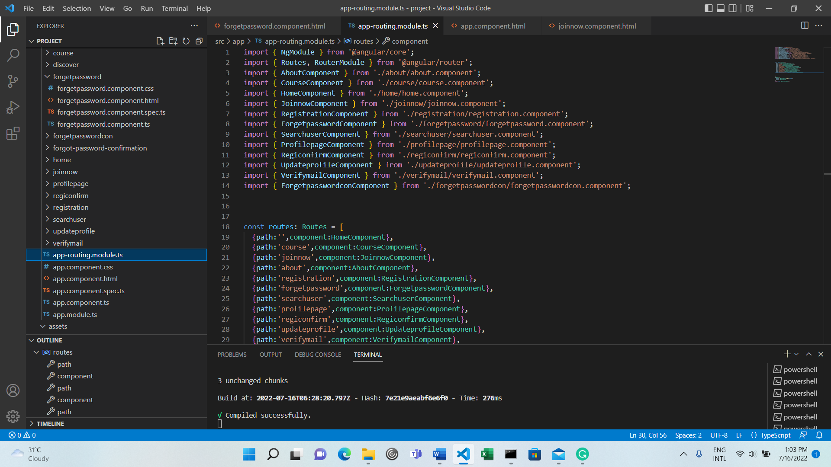**Visual Studio Code – To implement this Community portal**

Figure 1: Screenshot of visual studio code

* **Axure RP 10 – To create Prototypes**

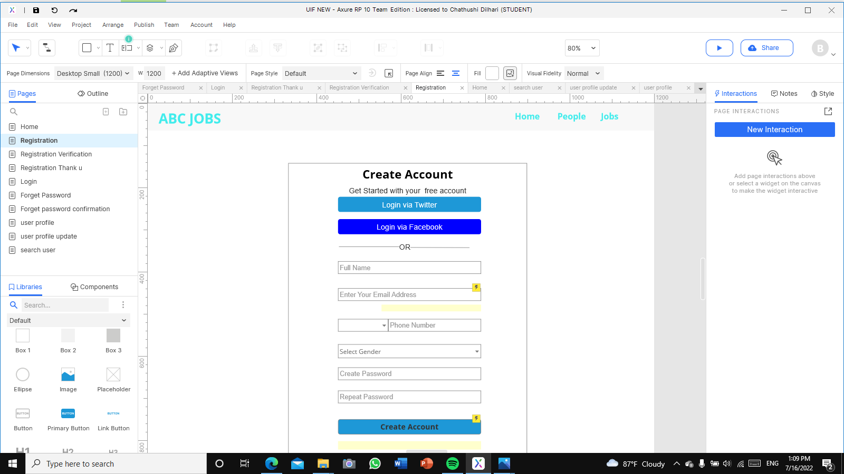

Figure 2: screenshot of axure RP 10

* **Angular CLI – To develop the application**

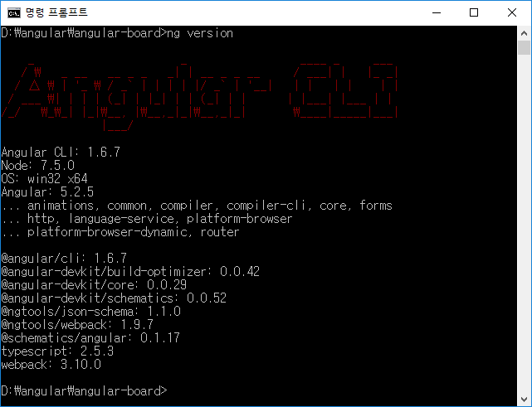

Figure 3:Screenshot of Angular CLI

* **formerly Draw.io - To create flow charts**

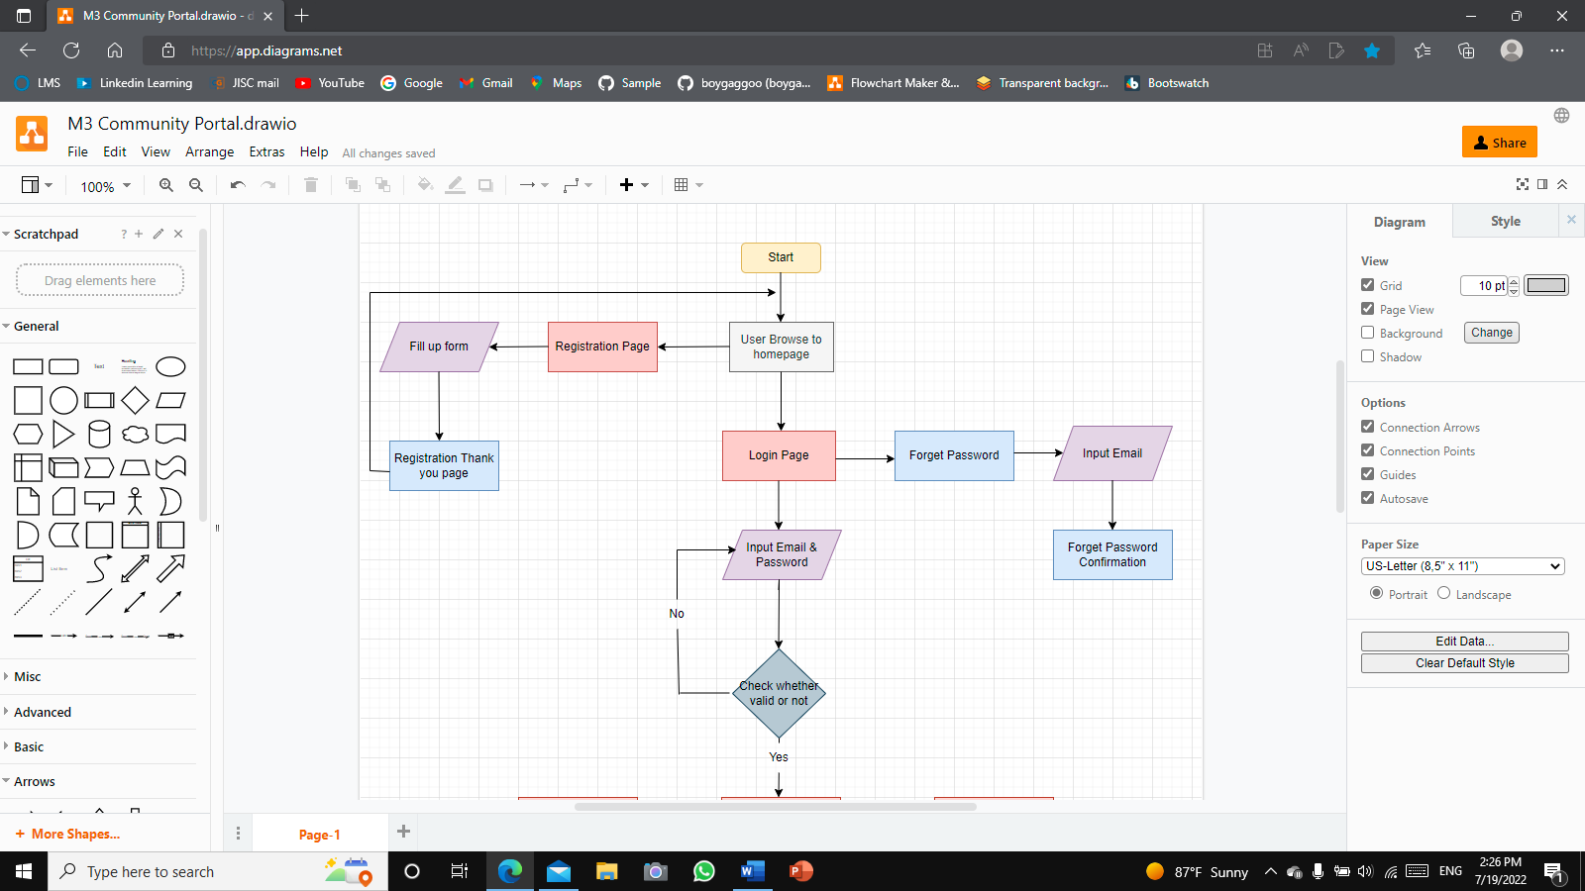

Figure 4:Screenshot of Regi.Drawio

* **Chrome Browser To run the application**

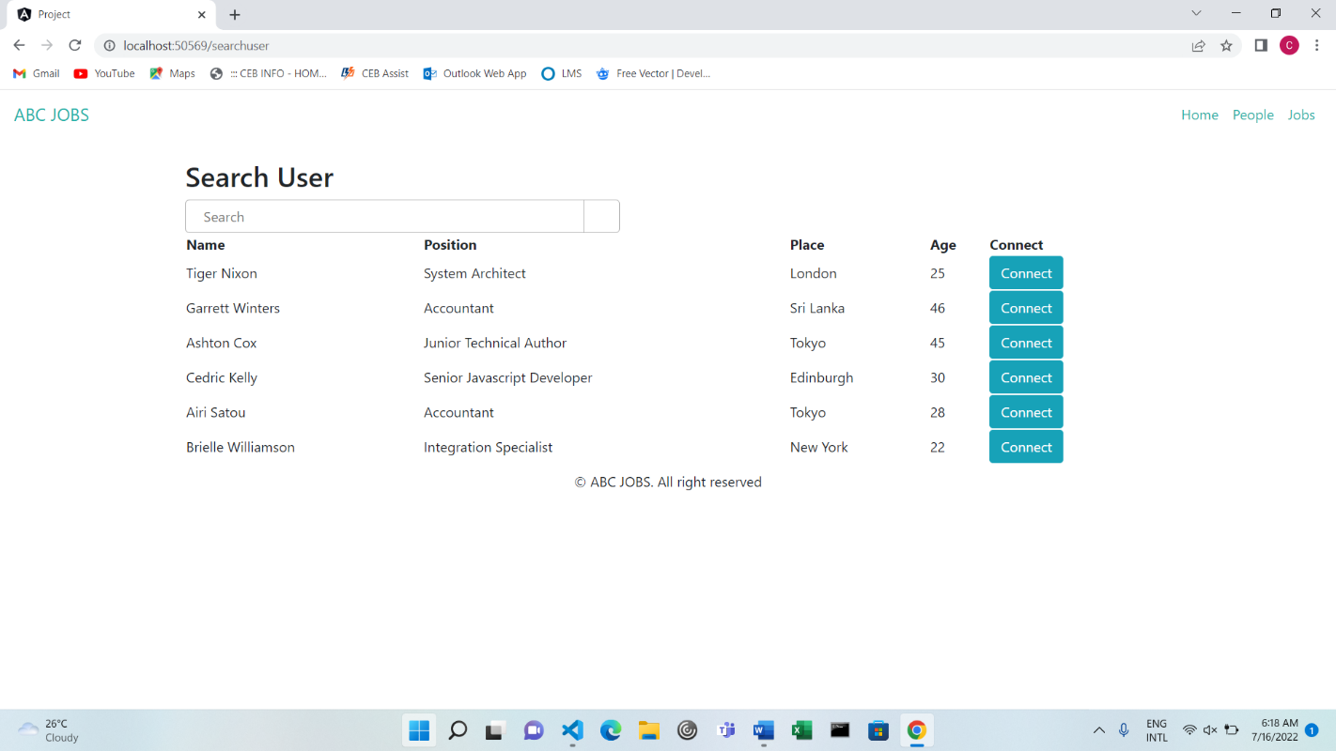

Figure 5:Screenshot of Google Chrome

* **Microsoft Excel – To calculation**

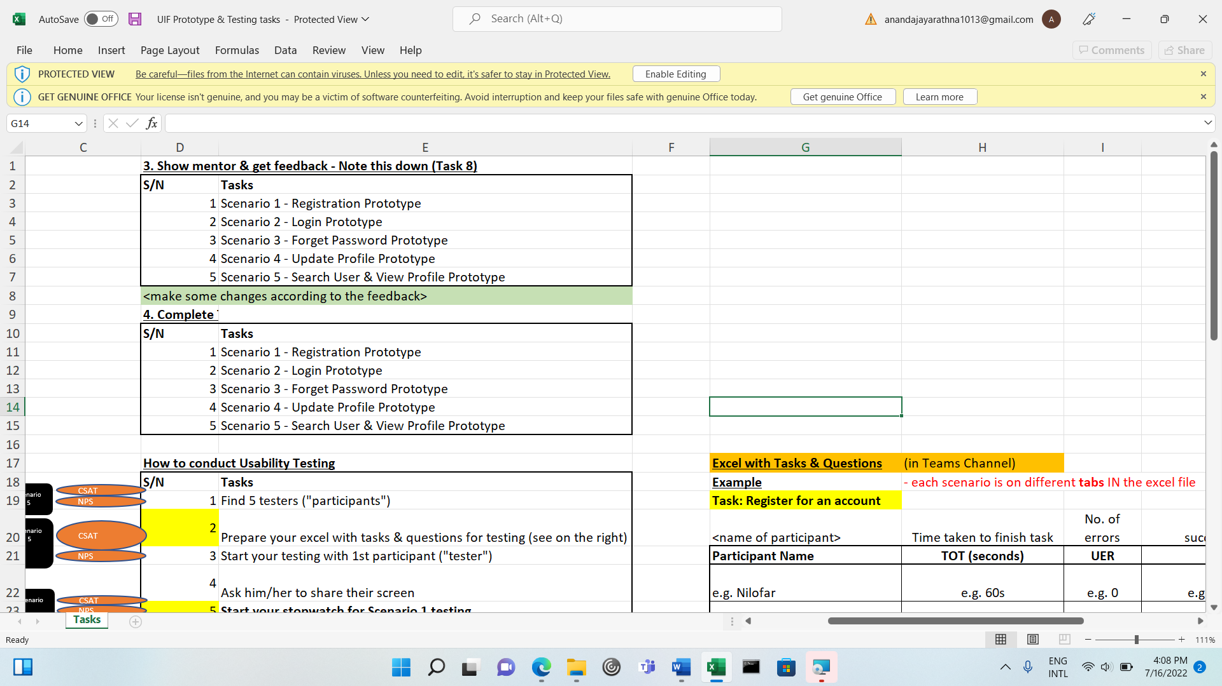

Figure 6:Screenshot of Microsoft Excel

* 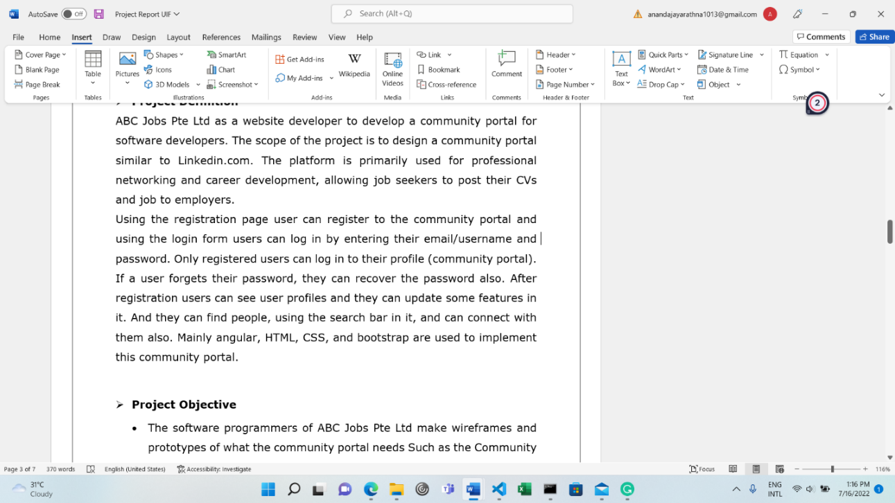**Microsoft Word – To create a project Report**

Figure 7:Screenshot of Microsoft Word

* 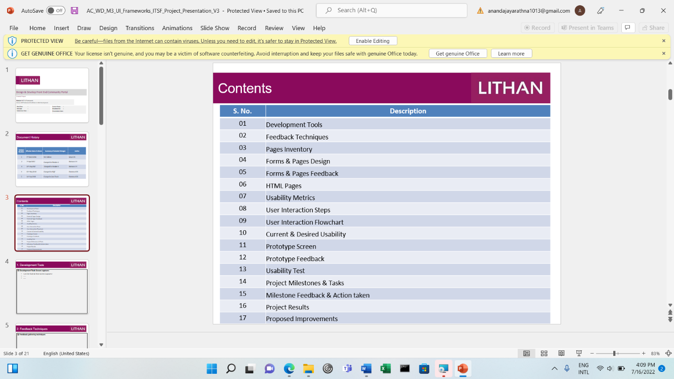**Microsoft PowerPoint – To create Project Presentations**

Figure 8: Screenshot of powerpoint

# Business Process and Solution Architecture

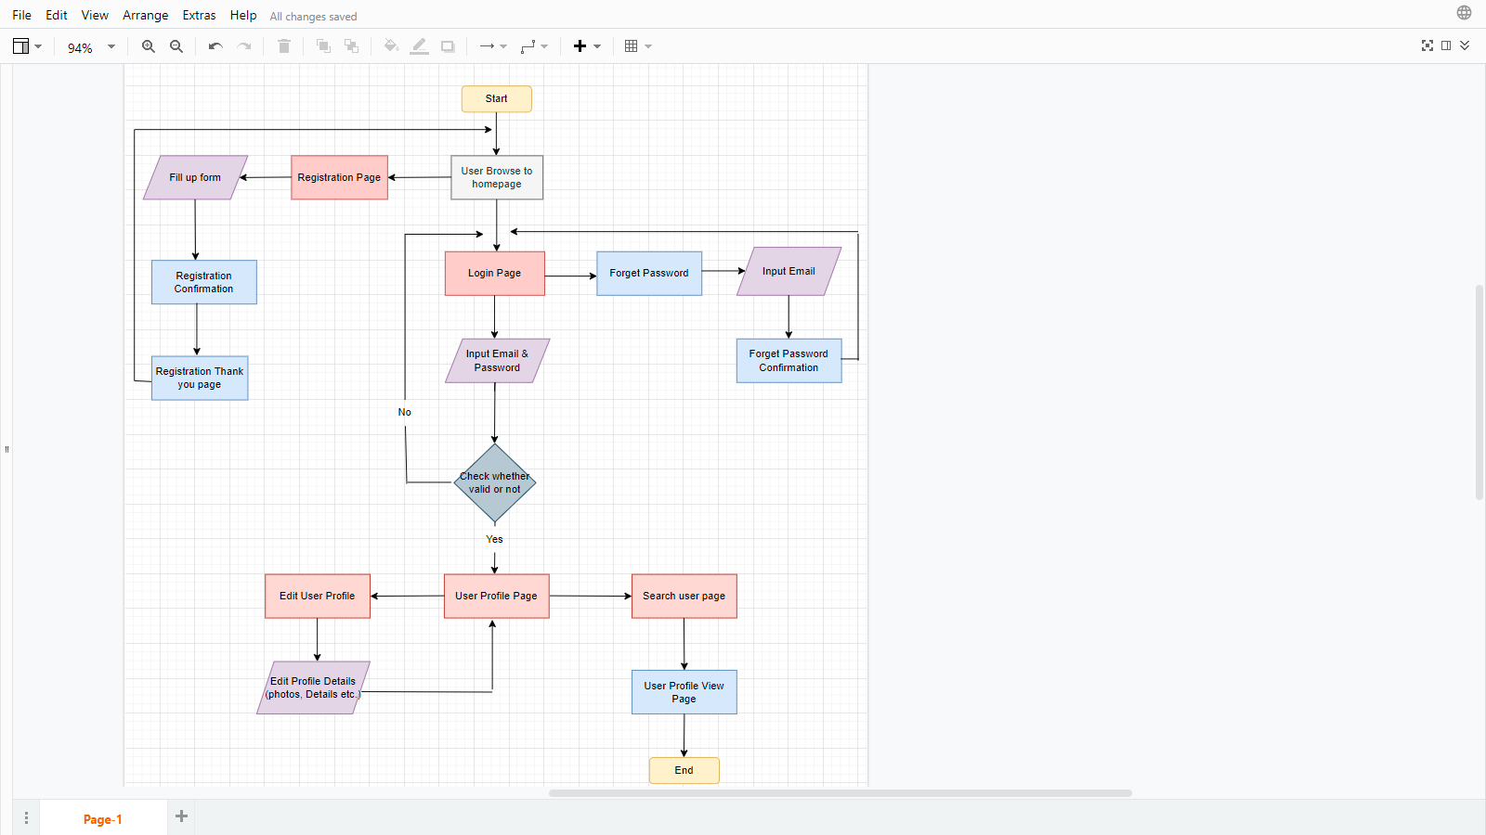

Figure 9:Business Process and Solution Architecture

|  |  |
| --- | --- |
| **Wireframes** | **Specifications (Widget Table)** |
| **Home Page** | |  |  |  | | --- | --- | --- | | Note number | Name | Interactions | | 1 | Hero Banner | Hero Image | | 2 | Sign Up Button | Link to registration | | 3 | Login Button | Link to Login | | 4 | Login button | Link to enter user profile | |
| **Login Page** | |  |  |  | | --- | --- | --- | | Note number | Name | Interactions | | 1 | Email Address | Text field to input email address | | 2 | Password | Text field to input password | | 3 | Forgot Password | Link to forgot password | | 4 | Login button | Link to enter user profile | |
| **Graphical user interface  Description automatically generatedRegistration Page** | |  |  |  | | --- | --- | --- | | Note number | Name | Interactions | | 1 | Login as Twitter button | Link to login twitter | | 2 | Login as Facebook button | Link to login Facebook | | 3 | Full name | Text field to input full name | | 4 | Email Address | Text field to input email | | 5 | Phone number code | Dropdown list to select country code | | 6 | Phone number | Text field to enter phone number | | 7 | Create Password | Text field to enter new password | | 8 | Repeat password | Text field to repeat password | | 9 | Create account button | Link to create account | |
| **Forgot Password page**  **Graphical user interface, application  Description automatically generatedForgot password Confirmation** | |  |  |  | | --- | --- | --- | | Note number | Name | Interactions | | 1 | Email Address | Text field to enter email | | 2 | Reset Password button | Link to rest password | | 3 | Register | Link to registration | | 4 | Forgot password | Link to Forgot password | | 5 | Login | Link to login |  |  |  |  | | --- | --- | --- | | Note number | Name | Interactions | | 1 | Forget Password Confirmation button | Link to login | |
| **Graphical user interface, text  Description automatically generatedUpdate Profile page** | |  |  |  | | --- | --- | --- | | Note number | Name | Interactions | | 1 | Profile photo | Update Profile photo | | 2 | Edit Profile button | Link to edit profile | | 3 | Name | Edit name text field | | 4 | Phone | Edit phone number text field | | 5 | Education | Add educations | | 6 | Skill | Add Skills | |  |  |  | |
| **A screenshot of a computer  Description automatically generatedSearch User Page** | |  |  |  | | --- | --- | --- | | Note number | Name | Interactions | | 1 | Search bar | Search user text field | | 2 | Lists of user | Search user list | | 3 | Connect button | Link to connect user profile | |

1. **Techniques and methods for gathering and analyzing user feedback.**

Live chats, short surveys, and social media are among the most common tools for gathering user feedback. Live chat is a way of direct communication with your customers. You can ask specific real-time questions or sort incoming feedback.

There are 2 types to collecting data, such as

* Quantitative

Quantitative data is, quite simply, information that can be quantified. It can be counted or measured, giving a numerical value such as length in centimeters or income in dollars. Quantitative data tend to be structured in nature and lend themselves to statistical analysis.

* Surveys, tests, or questionnaires – administered in groups, one-on-one, by mail, or online
* Reviews of records or documents using rubric: or
* Observations
* Qualitative.

Qualitative data refers to both descriptive and descriptive data. Quality data can be monitored and reported. This data type is non-numeric in nature.

* Shadow Sessions (Observe the user when using the program)
* A/B Testing (Compare between 2 programs and decide which one is better)

Understand the overview of the Community Portal from the Project Mentor.

|  |  |  |
| --- | --- | --- |
| **No** | **Questions** | **Answers** |
| 01 | What are the Community Portal that you are using? | LinkedIn |
| 02 | How many times a day do you use it? | About 3 or 4 times |
| 03 | From which device do you log in? | Laptop or mobile phone but mostly Laptop |
| 04 | Why do you use it? | Find out what’s going on in the IT (Software) industry. Such as what are the updated companies, what are the positions in those companies etc. |
| 05 | Can you share your experience with others? | Yes |

Persona

List the different personas who will be using the Community Portal, with a brief description of each of the personas.

|  |  |  |
| --- | --- | --- |
| **No** | **Persona** | **Brief Description** |
| 01 | Ashley (Unemployed) | Ashely is a 26 years old girl who is a web designer. She wants to be a web designer in the World Recognize IT Company |
| 02 | Kevin (Graduated) | Kevin is a 20 years old boy who is a school leaver. He archived excellent grades at GCE A/L Combined Maths, Physics, and IT and graduated from NSBM University. He is keen to pursue a career in the IT industry. |
| 03 | Nethu (Employed) | Nethu is 35 years old Nurse who cares for people recovering from surgery. Has been a nurse for 8 years. She likes having the opportunity to help people feel better. |

Create a Personas profile with Demographics, Behaviors & Beliefs, Characteristics & Goals for 2 Personas defined.

|  |  |
| --- | --- |
| Persona (1): | Kevin |
| Demographics: | 20 years, Male, Single, Sri Lanka, School Leaver |
| Behaviors and Beliefs: | Behaviors – Finding everything about computer software  Beliefs - “Cast your net wide. Be courageous about meeting people, about having a go at something you haven’t done before.” |
| Characteristics: | Hard-Working  Active  Brave |
| Goals: | To be a Software Developer, Hacker |

|  |  |
| --- | --- |
| Persona (2): | Nethu |
| Demographics: | 35 years, Female, Married, Romania, Nurse |
| Behaviors and Beliefs: | Behaviors – Finding all-new medical methods in the world  Beliefs – “I can do anything I want to do” |
| Characteristics: | Hard-working  Responsible |
| Goals: | More interactions with patients  She wants to provide the best care |

# User Experience on 2 community portal websites

1. **Linkedin.com**

When I visit linkedin.com, my eyes are instantly drawn to a beautiful color combination. The text is easy to read and easy to find what I want to do. Then I tried to register by clicking the "join now" button. The registration form was good and easy to fill with validation to avoid user errors. After signing up I logged in and it was very smooth transitioning from page to page. I like the flow of the site.

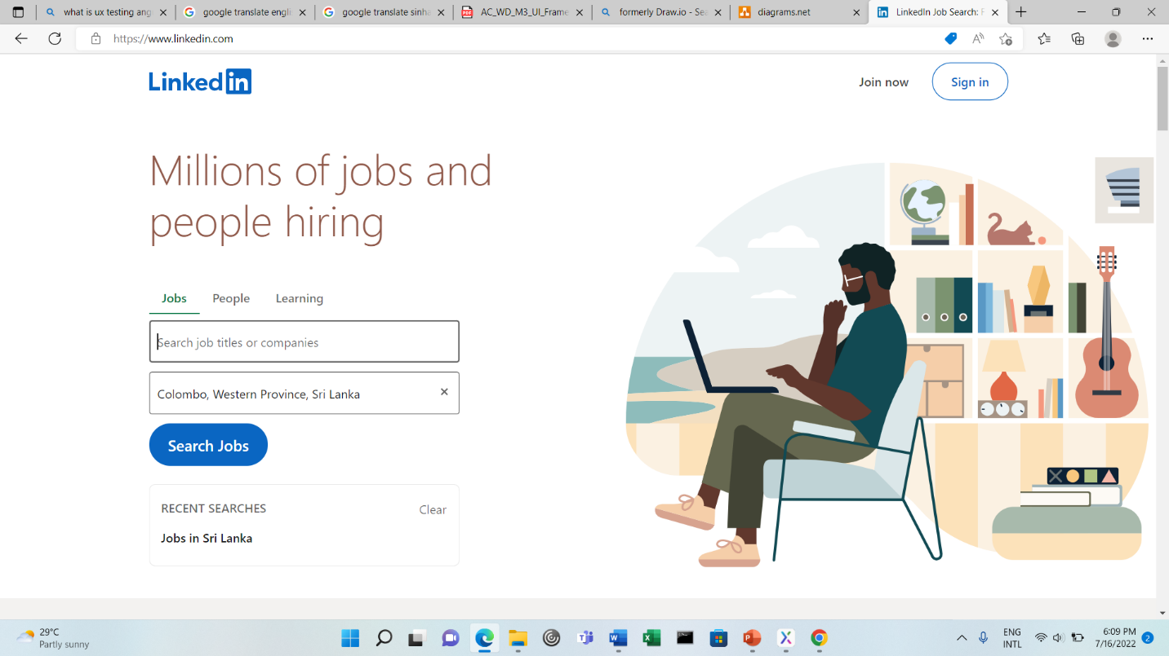

Figure 10:Screenshot of LinkedIn

1. **Glassdoor.com**

When I go to the glassdoor website, the home page is not really good when I first arrive on the website. We can directly use this community portal. I tried to register to the website. It takes little time to sign up process. They also provide way to register with google or Facebook that speeds up the registration progress for me. After that I tried to log in to the website and overall the layout and color of the website is very good and I like the color too.

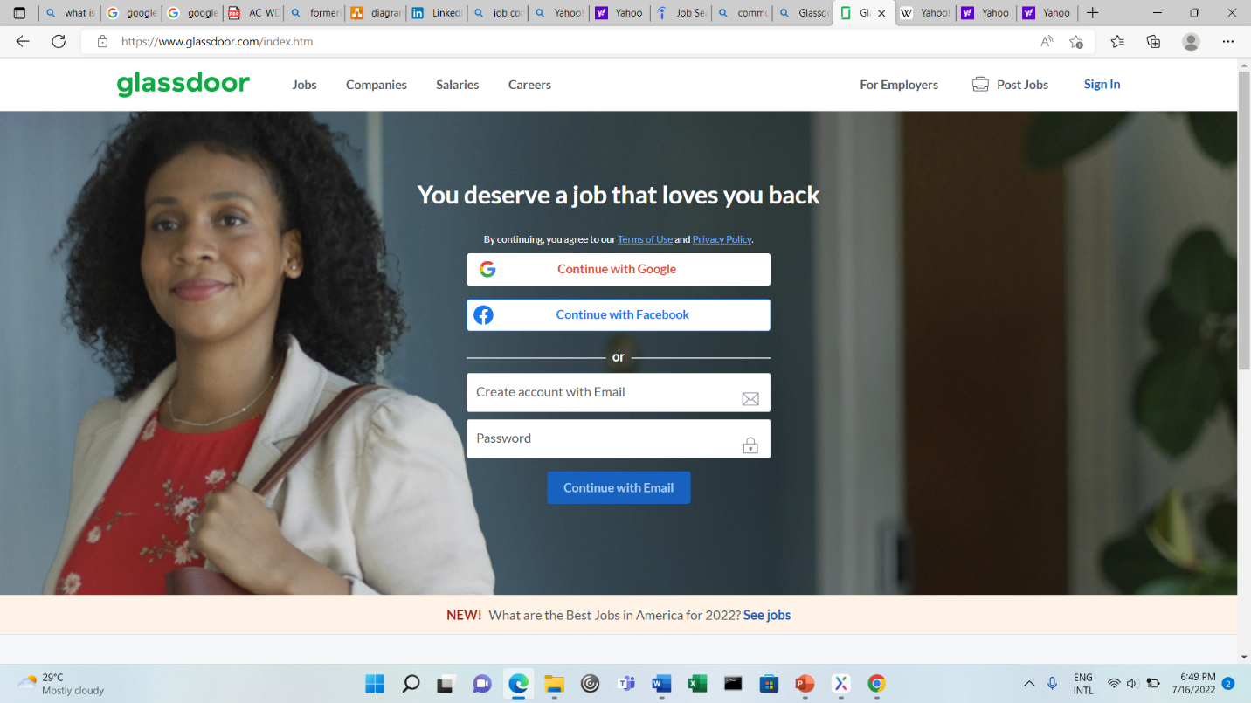

Figure 11:Screenshot of Glassdoor.com Home Page

# Analyze the user experience based on the observations

* **Likdein.com**
* Scenario - Register Page

The opportunity to register on Linkedin.com is a great experience. The way the registration form pops up first displayed 2 fields, email and password, this way the user won't experience too many forms at once and won't get bored fast. Validation also alerts users for invalid or incorrect data entry. Linkedin.com also provides registration with Google, which speeds up the process of registering on the site. The page color is nice and simple.

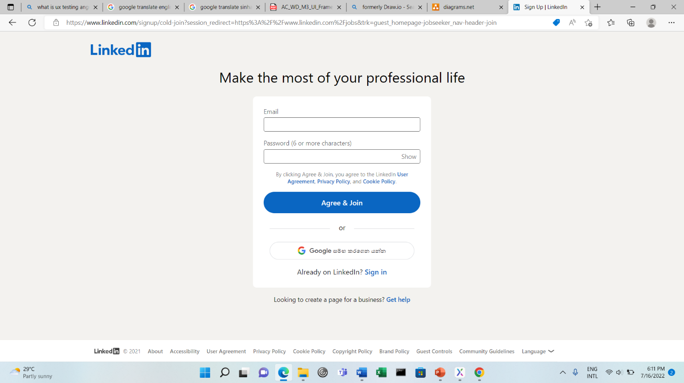

Figure 12:Screenshot of LinkedIn Registration Form

* Scenario: Login Page

Linkedin.com login option provides a "Show" password feature, so if the user types in the correct password, it's easy. The login page also provides a forgotten password, which is great for users who have forgotten their password. The Linkedin.com login page also has a feature to remember login history, so when you log out and want to log back in, you need to click on your previous account and type the password again to enter the page.

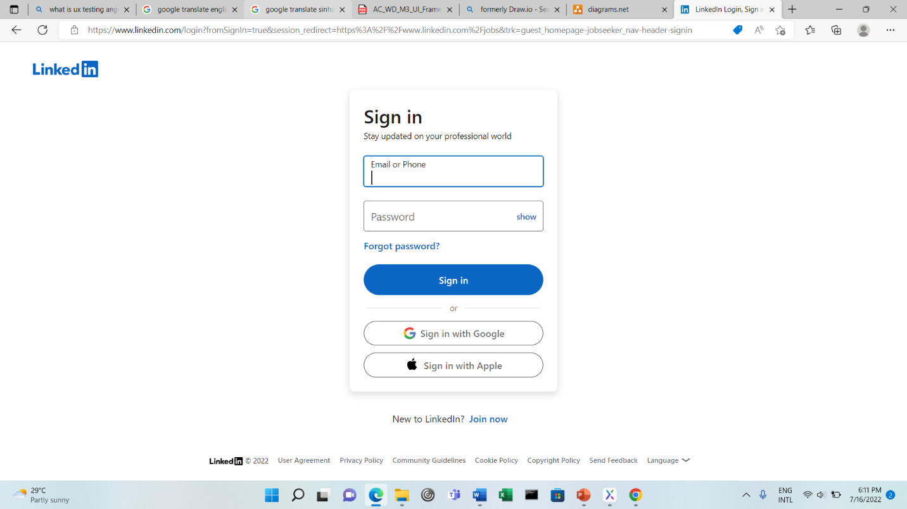

Figure 13:Screenshot of LinkedIn Login Form

* **Glassdoor.com**
* **Scenario: Registration**

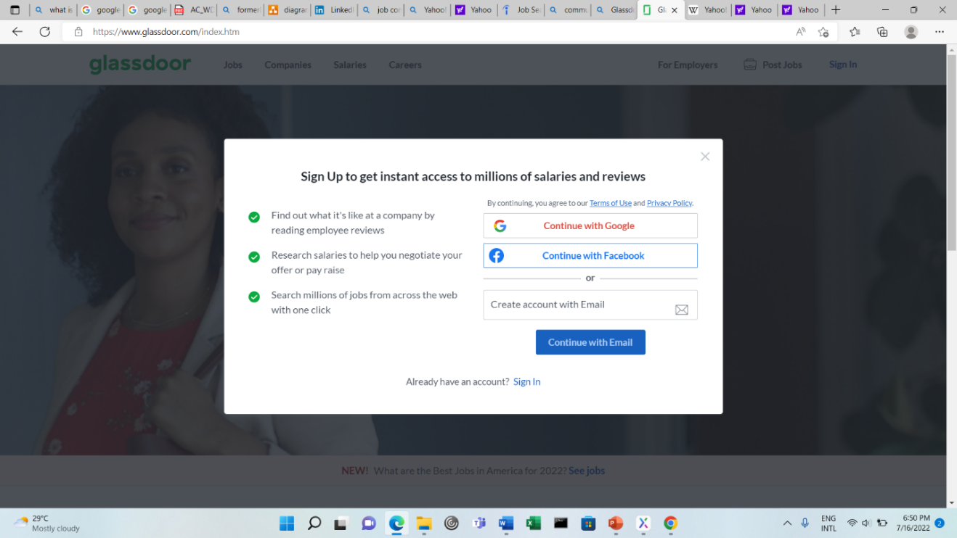The opportunity to register on Glassdoor.com is a great experience. The way the registration form pops up first displayed 2 fields, email and password, this way the user won't experience too many forms at once and won't get bored fast. Validation also alerts users for invalid or incorrect data entry. Glassdoor.com also provides registration with Google and Facebook which speeds up the process of registering on the site. The page color is nice and simple

Figure 14:Screenshot of Glassdoor Registration

* Scenario: Login

Glassdoor.com login option is directly provided in the home page. User can easily log in to this community portal. They added validations also. So if the user types in the correct password, it's easy. The login page also provides a forgotten password, which is great for users who have forgotten their password. The Glassdoor.com login page also has a feature to remember login history, so when you log out and want to log back in, you need to click on your previous account and type the password again to enter the page.

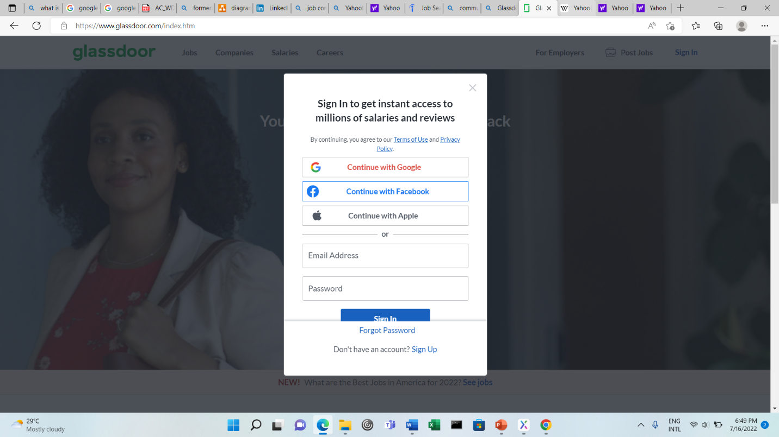

Figure 15:Screenshot of Glassdoor Login

1. The performance level & gaps between user experience & desired user experience along with level of user engagement

|  |  |  |  |  |
| --- | --- | --- | --- | --- |
| * **LinkedIn.com** | | | | |
| **Scenario** | **TOT (seconds)** | **Expect TOT** | **Performance Gaps** | **UER** |
| Register | 65 | 60 | 5 | 2 |
| Login | 20 | 22 | 2 | 0 |
| Forgot Password | 40 | 70 | 30 | 0 |
| * **Glassdoor. com** | | | | |
| **Scenario** | **TOT (seconds)** | **Expect TOT** | **Performance Gaps** | **UER** |
| Register | 50 | 60 | 10 | 0 |
| Login | 30 | 20 | 10 | 2 |
| Forgot Password | 40 | 22 | 18 | 0 |

..

1. Develop and Document 3 user metrics

* TOT (Time on Task): How long the time that user take to complete the task
* UER (User Error Rate): Number of the mistakes that user make
* TSR (Task Success Rate): Success or fail when do the task. Success is 1 and fail is 0
* 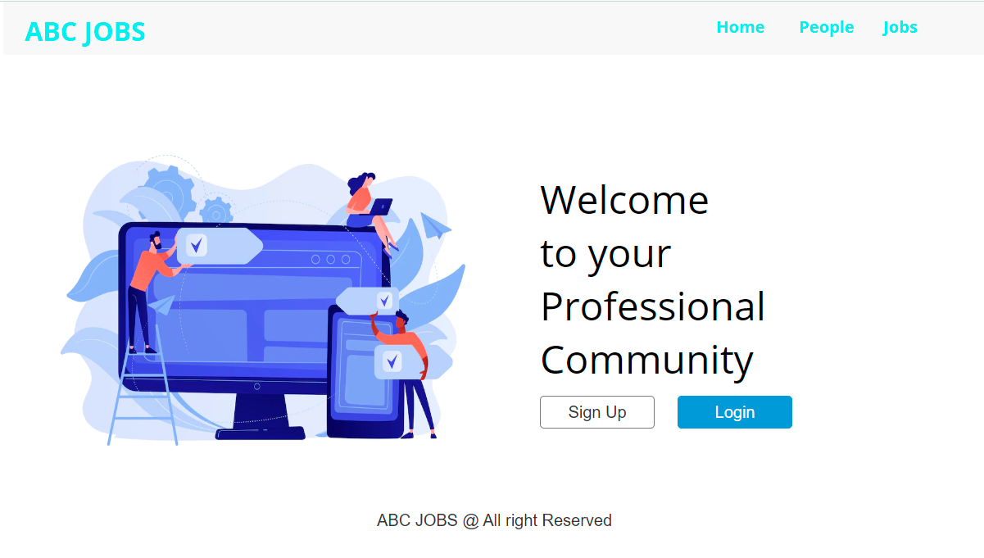Home Page

Figure 16:Screenshot of home page(prototype)

..

* Login Page

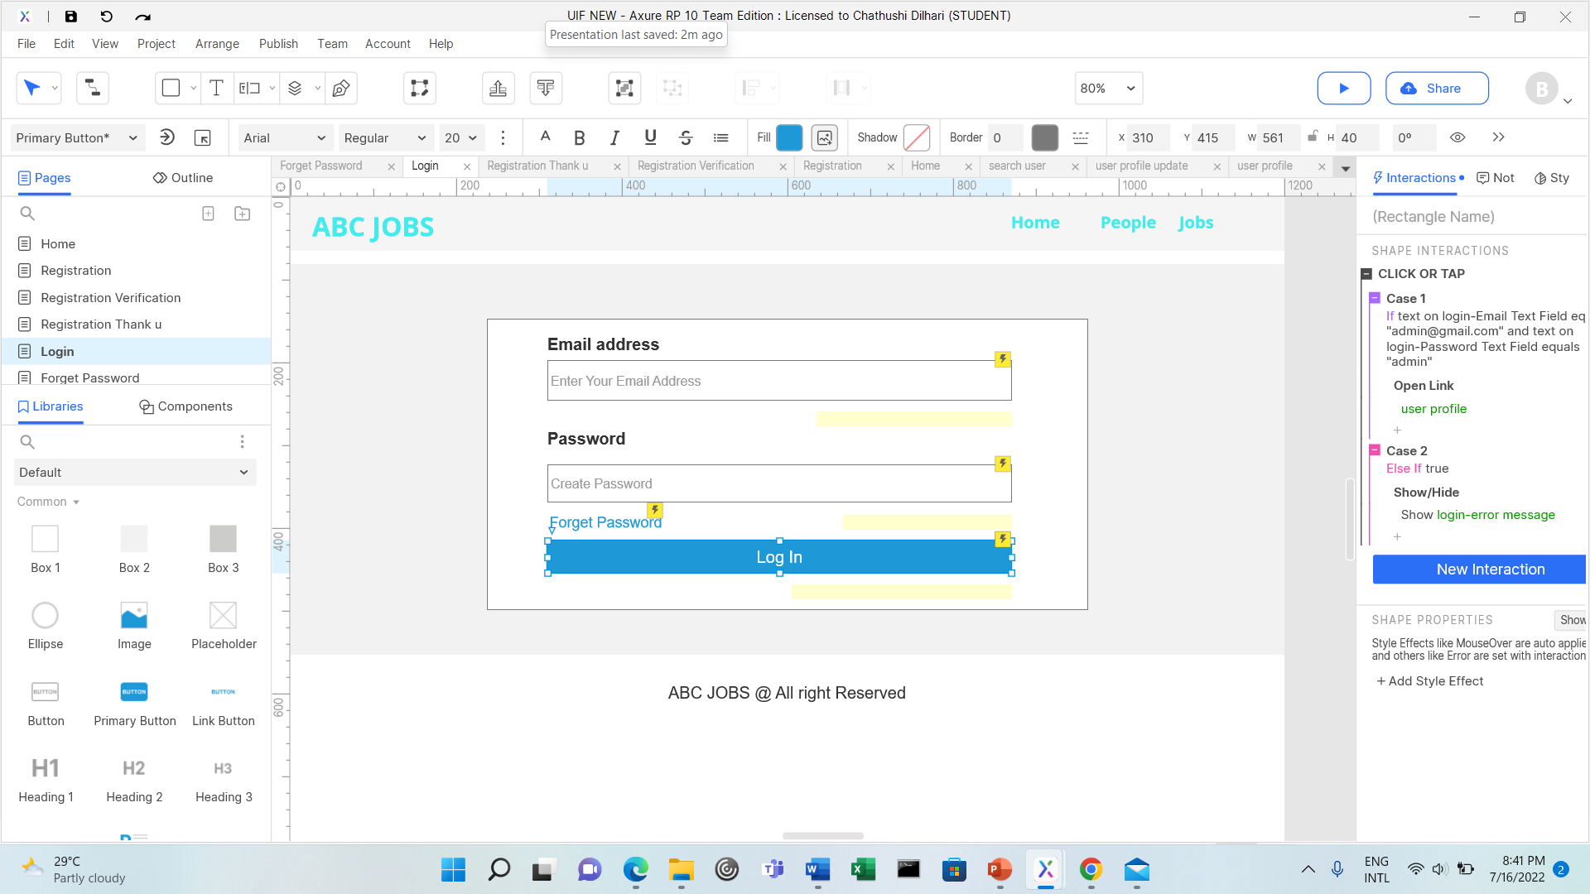

Figure 17:Screenshot of Login page (prototype)

* Forgot Password Page

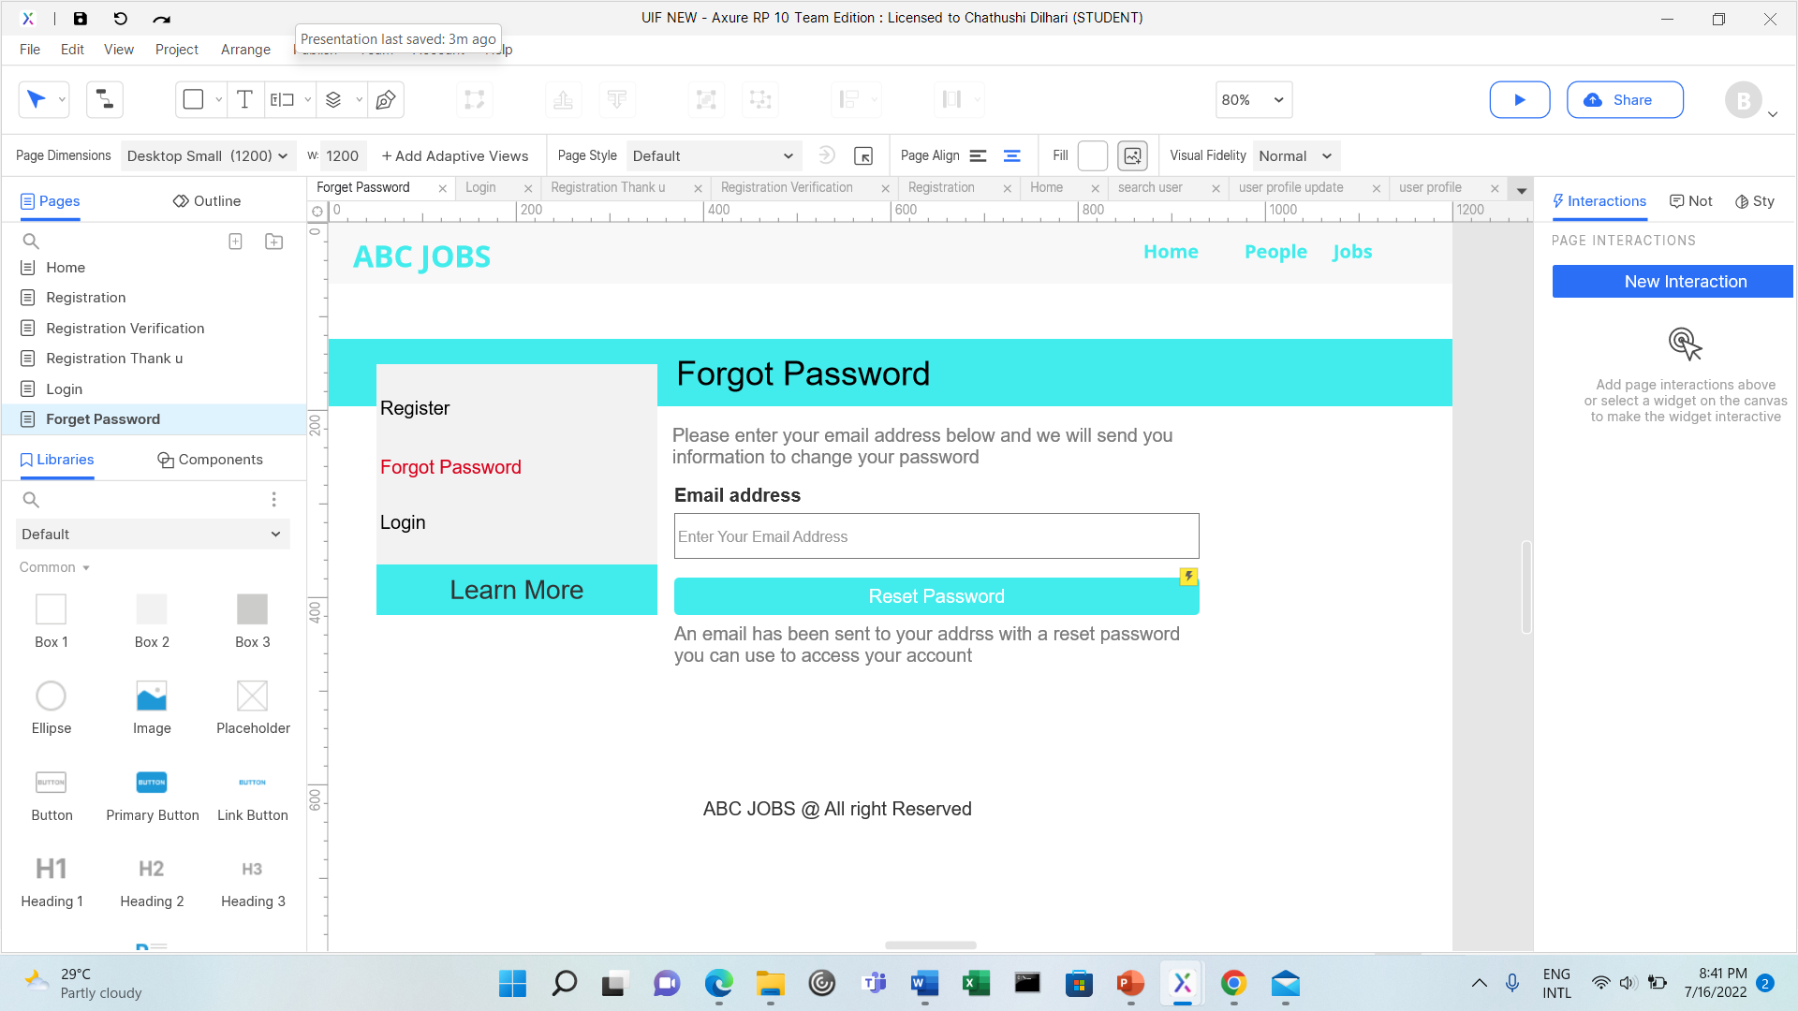

Figure 18:Screenshot of forgot password(prototype)

* 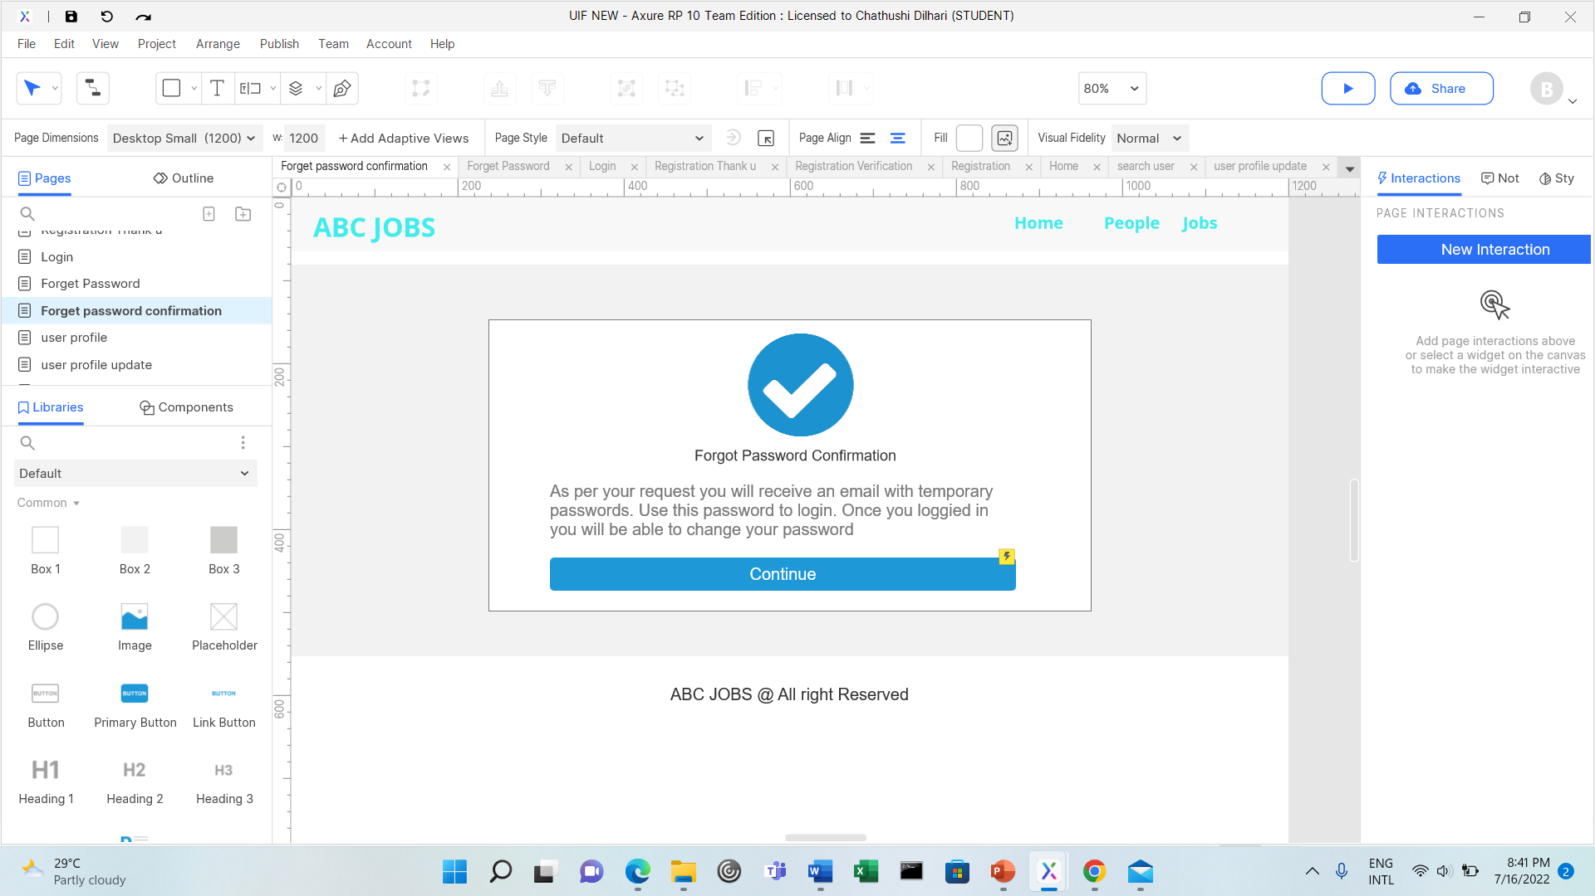Forgot Password Confirmation

Figure 19:Screenshot of forgot password confirmation (prototype)

* Registration Page

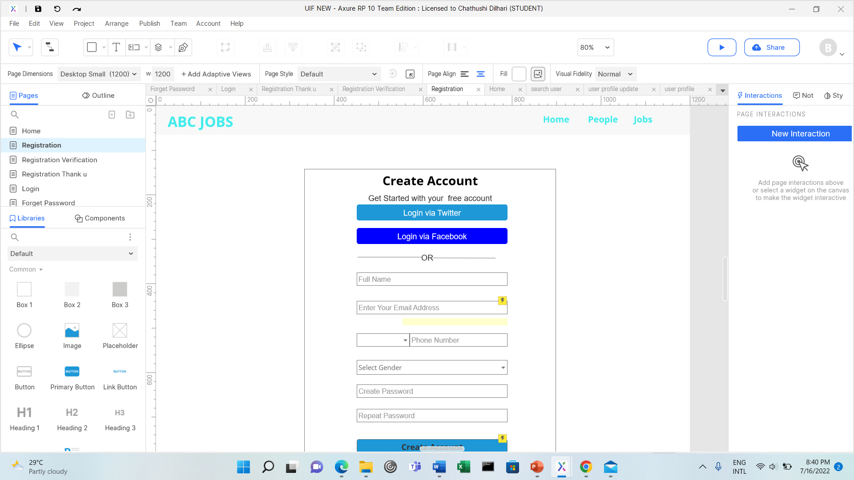

Figure 20:Screenshot of registration (prototype)

* Registration Confirm Email

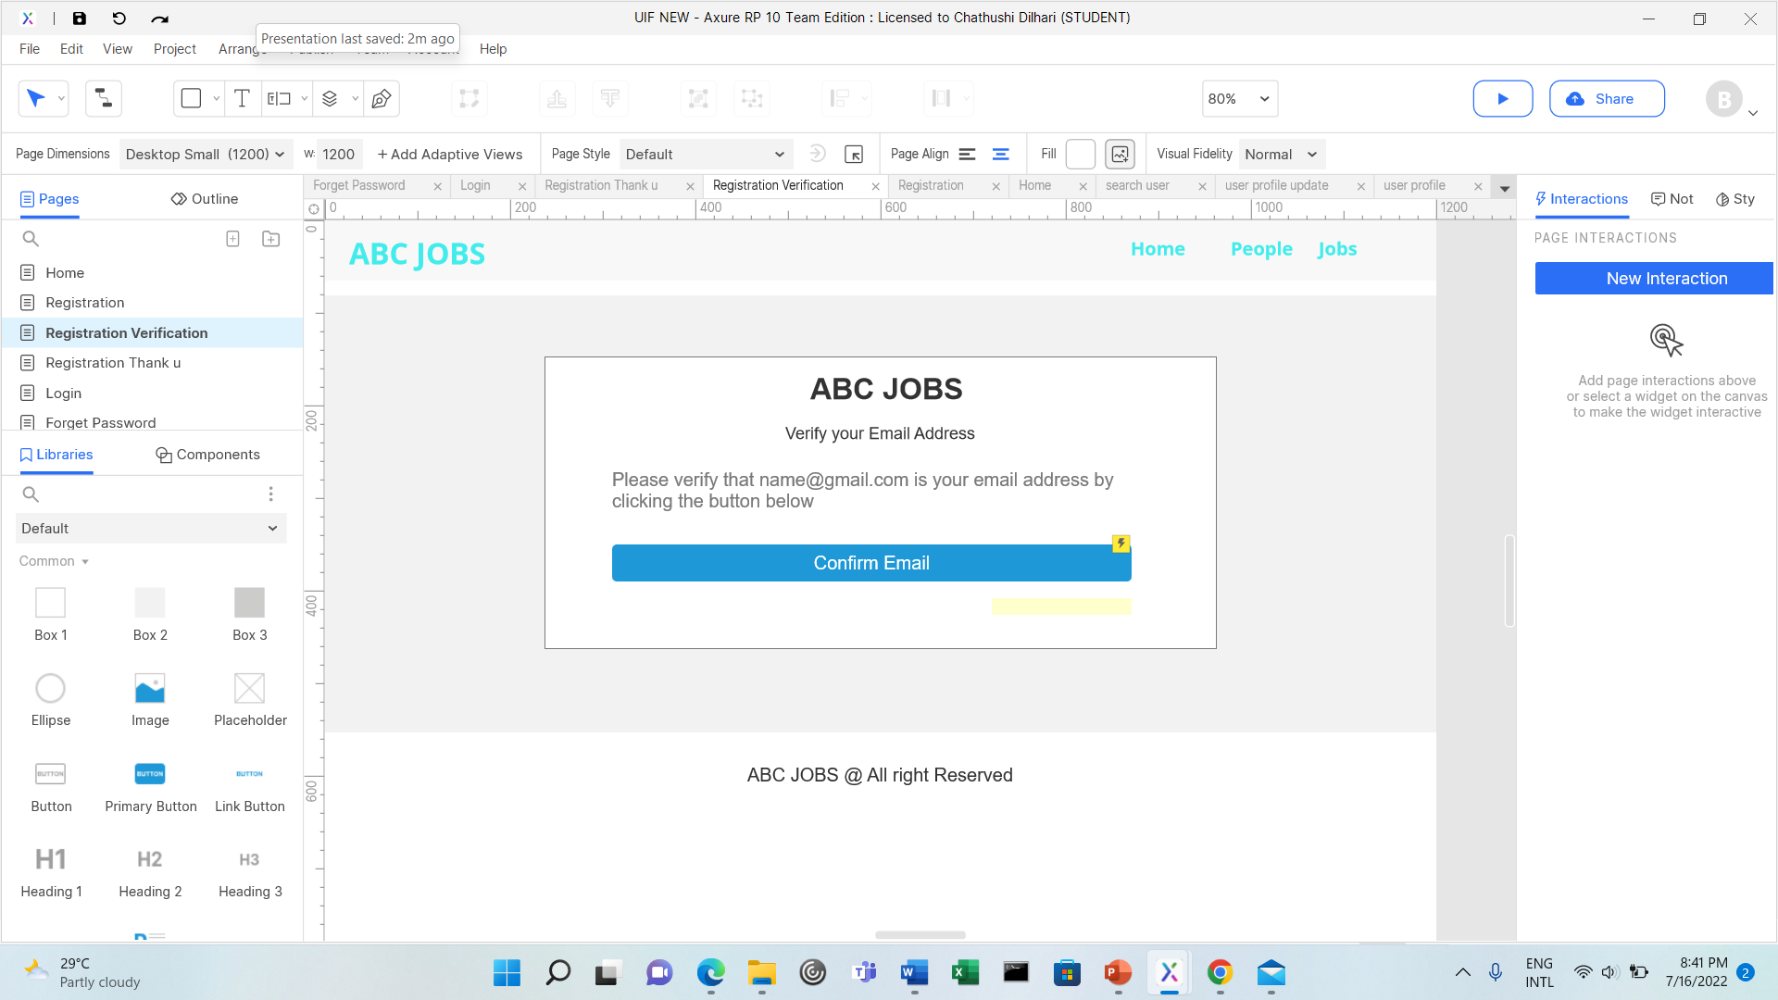

Figure 21:Screenshot of registration confirmation (prototype)

* Registration Thank you

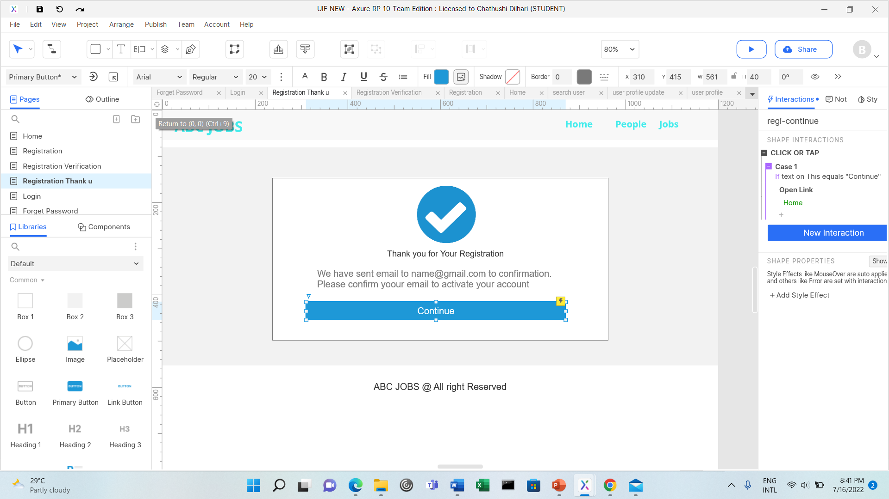

Figure 22:Screenshot of registration thank you page (Prototype)

* 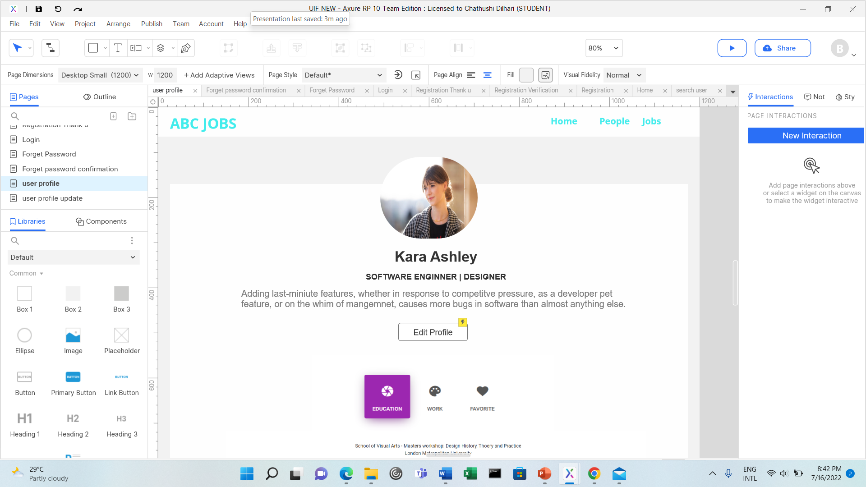User Profile Page

Figure 23:Screenshot of user profile page (prototype)

* Update Profile Page

Figure :Screenshot of update profile (prototype)

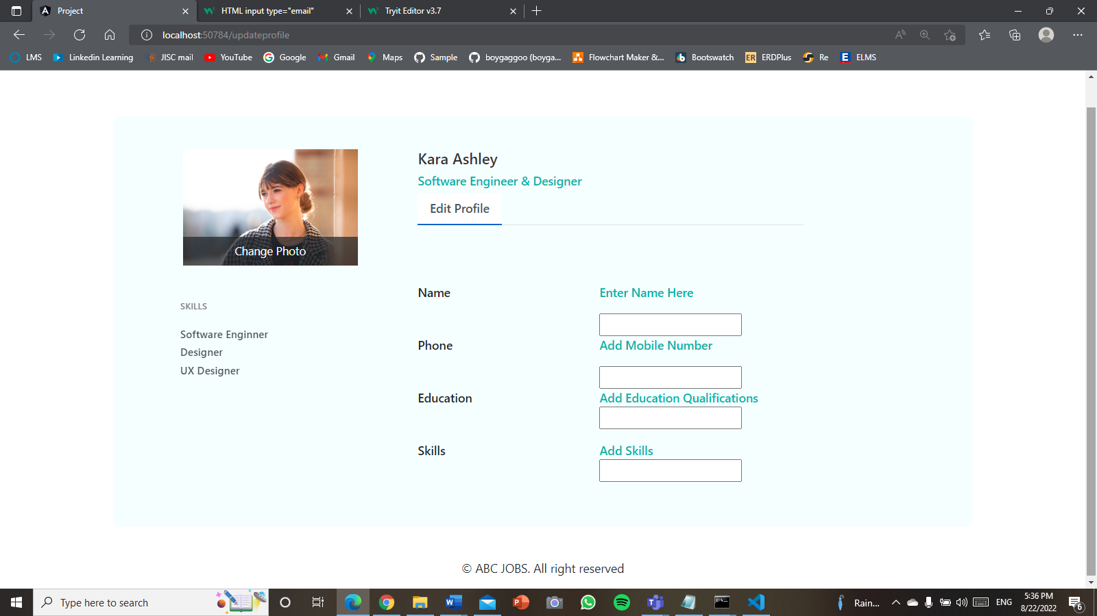

* 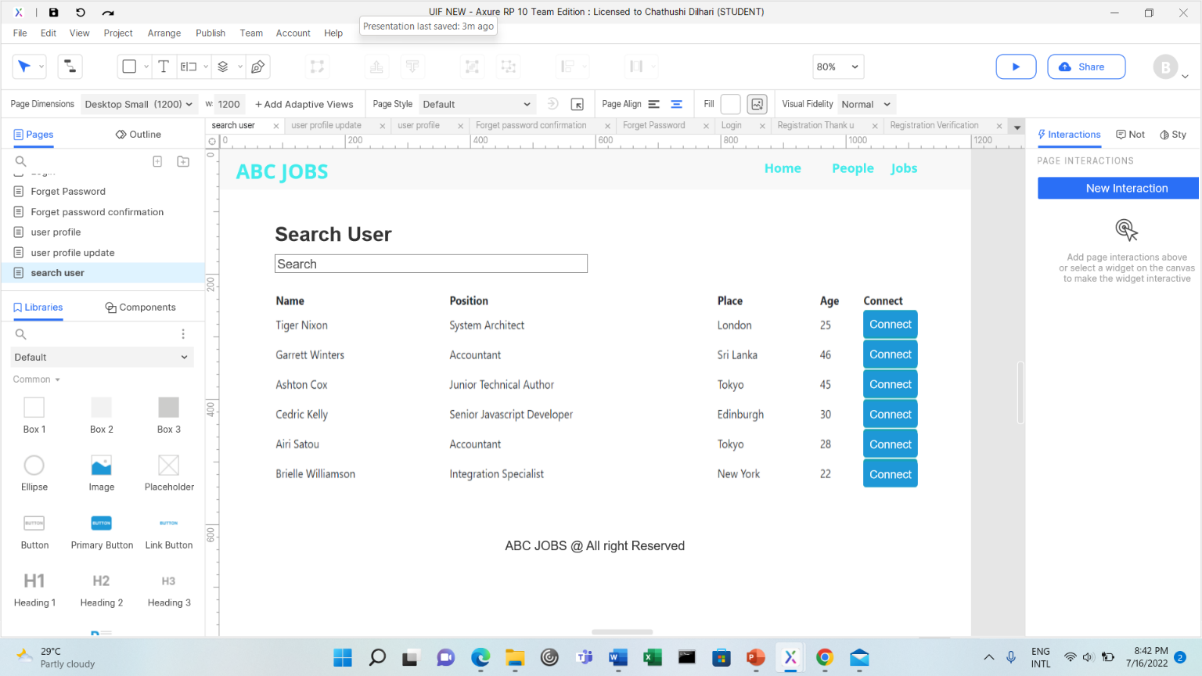Search User Page

Figure 25:Screenshot of search user page (prototype)

1. **User Interaction Process along with the flow chart**

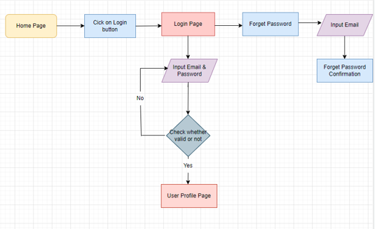**Scenario 1: Login Page**

Figure 26:Screenshot of flow of Login

|  |
| --- |
| **Interaction Process** |
| **Form Portal Home Page**   * User clicks on “Login” button link and reaches the Login page * User is required to key in all the required information (Email address and password) * Upon clicking on the login button validation checks will be performed and error messages will be promoted * If cannot remember password user can click “Forgot password” link and reaches the forgot password page to reset password * User is required to add email address * Upon clicking on reset password button user can reset password * If their no invalid details user will enters to the community portal successfully |

**Scenario 2 : Registration Form**

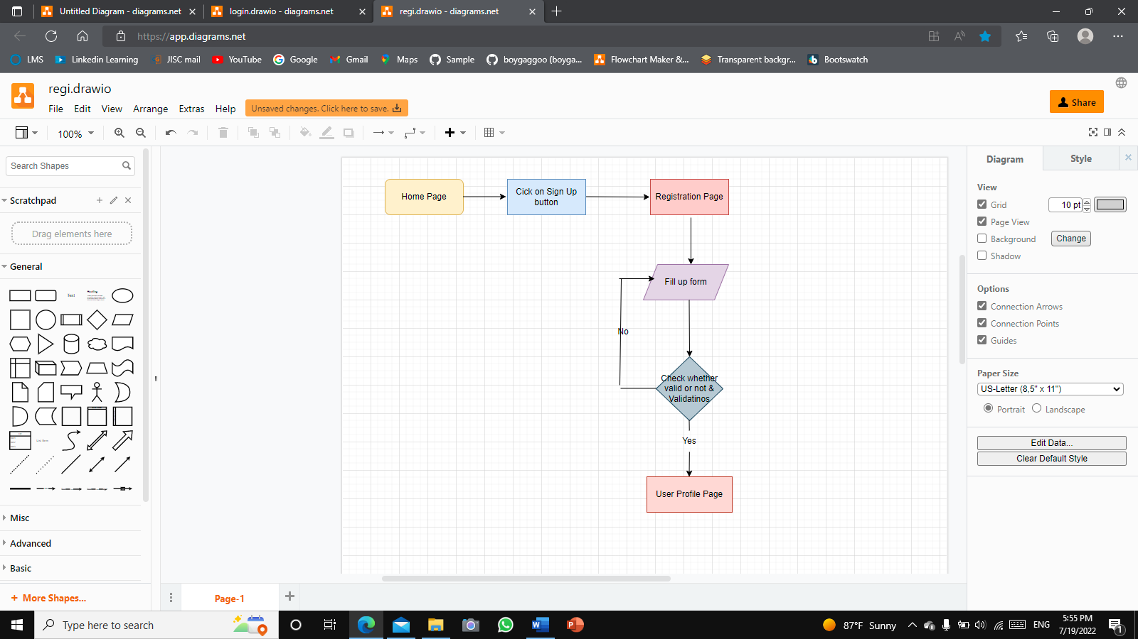

|  |
| --- |
| Interaction Process |
| Form initial home page   1. User click on the “sign up” button reaches the login page. 2. User is required to key in the required information(first name last name email and password) and click on the “sign up” button 3. Upon clicking on the sign-up button, validation checks will be performed and error messages will be prompted to the user if any required information is missing. 4. Displaying the Registration confirmation page 5. Upon clicking on the “Continue” button reaches the registration confirmation mail page 6. Upon clicking the “Verify Email address” button reaches the Login page 7. User clicking “sign in” link reaches the login page |

Figure 27:Screenshot of Flow of Registration

1. File for the details of the widget prototypes

* Registration Page



Figure 28:Screenshot of Registration Page

|  |  |  |  |
| --- | --- | --- | --- |
| Note number | Name | Interaction | Note |
|  | Email Address |  | Text field to input email |
|  | Create account button |  | Link to create account |

..

* **Login Page**



Figure 29:Screenshot of Login page

|  |  |  |  |
| --- | --- | --- | --- |
| Note number | Name | Interactions | Note |
| 1 | Email Address |  | Text field to input email address |
| 2 | Password |  | Text field to input password |
| 3 | Forgot Password |  | Link to forgot password |
| 4 | Login button |  | Link to enter user profile |

* Home Page

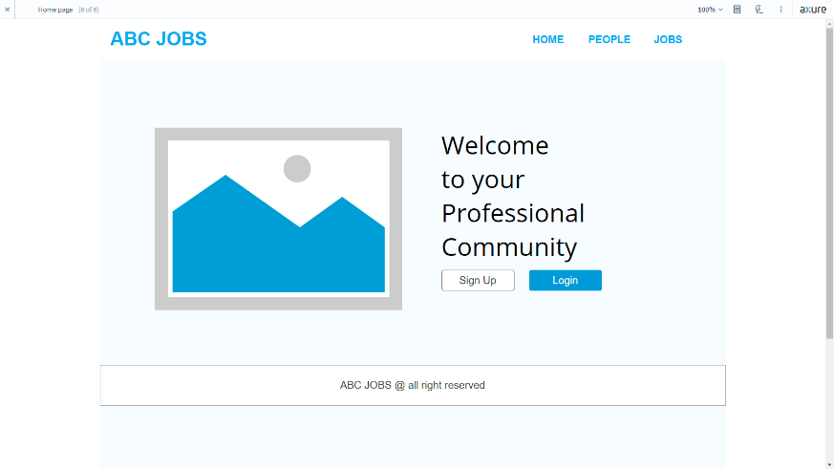

Figure 30:Screenshot of Home page

|  |  |  |  |
| --- | --- | --- | --- |
| Note number | Name | Interactions | Note |
| 1 | Sign Up Button |  | Link to registration |
| 2 | Login Button |  | Link to Login |

1. Usability tests and execute the usability test with a user

* **Registration**

|  |  |  |  |  |  |
| --- | --- | --- | --- | --- | --- |
| Participant Name | TOT (Seconds) | UER | TSR | Observation | Feedback |
| Chathu | 47 | 0 | Success | All good | No feedback |
| Tharuka | 53 | 2 | Success | Not entering phone code | Easy to register |
| Thusith | 39 | 1 | Success | Not select gender | Better to add county field |
| Cara | 41 | 0 | Success | All good | You could make the font size little bit bigger |
| Rahul | 43 | 0 | Success | All good | Change colors |

|  |  |  |  |
| --- | --- | --- | --- |
|  | TOT | UER | TSR |
| Average Score | **30** | **30%** | **100%** |

**Analysis & Suggested**

* password input field not yet been added a show password feature

**Improvements**

* adding validations for text fields
* **Update Profile**

|  |  |  |  |  |  |
| --- | --- | --- | --- | --- | --- |
| Participant Name | TOT (Seconds) | UER | TSR | Observation | Feedback |
| Chathu | 32 | 0 | Success | All good | Try to add profile cove |
| Tharuka | 52 | 1 | Success | Trying to change email | Add dark colors |
| Thusith | 44 | 0 | Success | All good | You could make the font size little bit bigger |
| Cara | 32 | 1 | Success | Trying to change email | No feedback |
| Rahul | 20 | 0 | Success | All good | Add other qualification section |

|  |  |  |  |
| --- | --- | --- | --- |
|  | TOT | UER | TSR |
| Average Score | 36% | 28% | 100% |

**Analysis & Suggested**

* add phone number change filed

|  |  |  |  |
| --- | --- | --- | --- |
| **CSAT** |  |  | |
|  | | | |
|  | **Participant Name** | **Satisfaction Score** | **Reason** |
|  | Chathu | 9 | Good color palette |
|  | Tharuka | 10 | Easy to Handle |
|  | Thusith | 7 | Cool website |
|  | Cara | 8 | Superb website |
|  | Rahul | 8 | like the color |
|  | | | |
|  | **Average CSAT Score** | 20% |  |
|  | | | |
| **NPS** |  |  | |
|  | | | |
|  | **Participant Name** | **Promoting Score** | **Reason** |
| Chathu | 9 | Good functionality |
| Tharuka | 5 | Could be improved at some point |
| Thusith | 9 | Easy to use |
|  | Cara | 8 | Easy to handle |
|  | Rahul | 7 | Cool website |
|  | | | |
|  | **NPS** | 40% |  |

1. Gather feedback for the prototypes and document, make suggestions for improvement.

|  |  |  |  |
| --- | --- | --- | --- |
| c | Forms / Pages | Feedback Received | Modifications Implemented |
| **01** | **Update Profile Page** | **It would be great if you could upload a cover photo** | **Add cover photo section** |

* **Before**

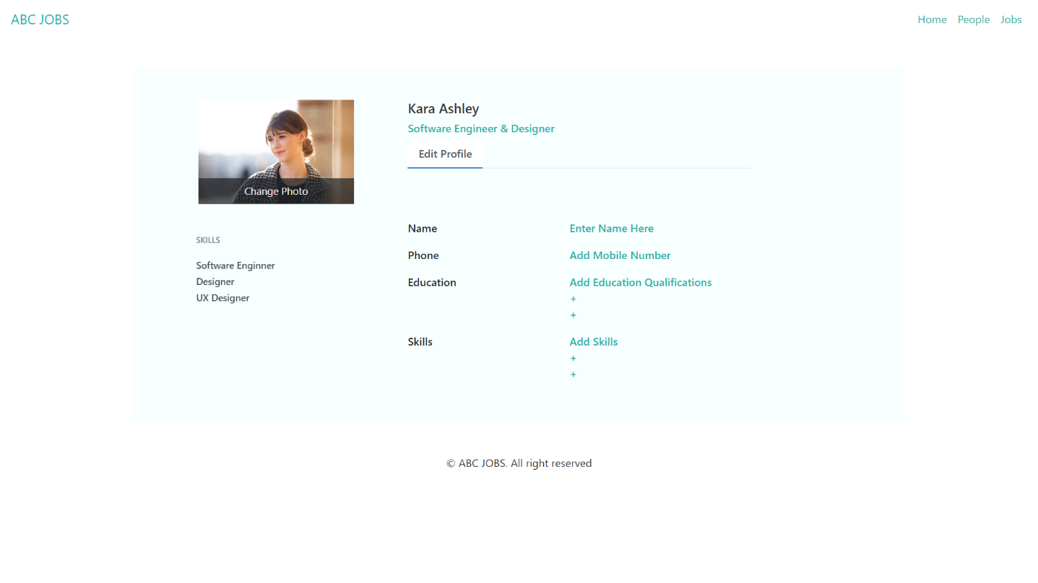

Figure 31:Screenshot of profile page before edit

* **After**

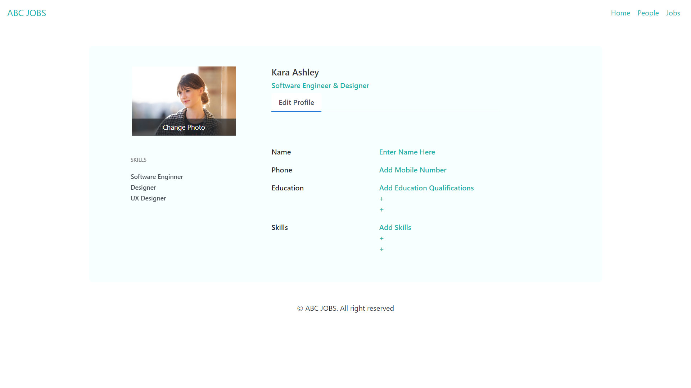



Figure 32:Screenshot of profile page after edit

1. **Prototype and Wireframe File**

